**UpGrad Course 5-Capstone Project**

GitHub :<https://github.com/PrashanthGanta/DevOps_Kubernetes>

# **Task 1: Setup EKS Cluster**

AWS Configuration

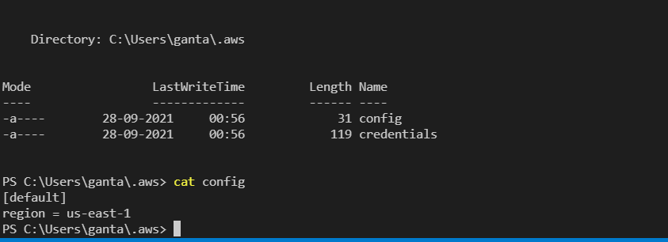

Terraform-configuration

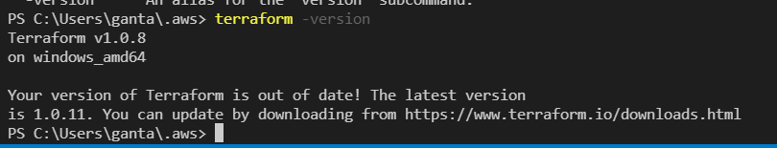

VPC- Creation

VPC

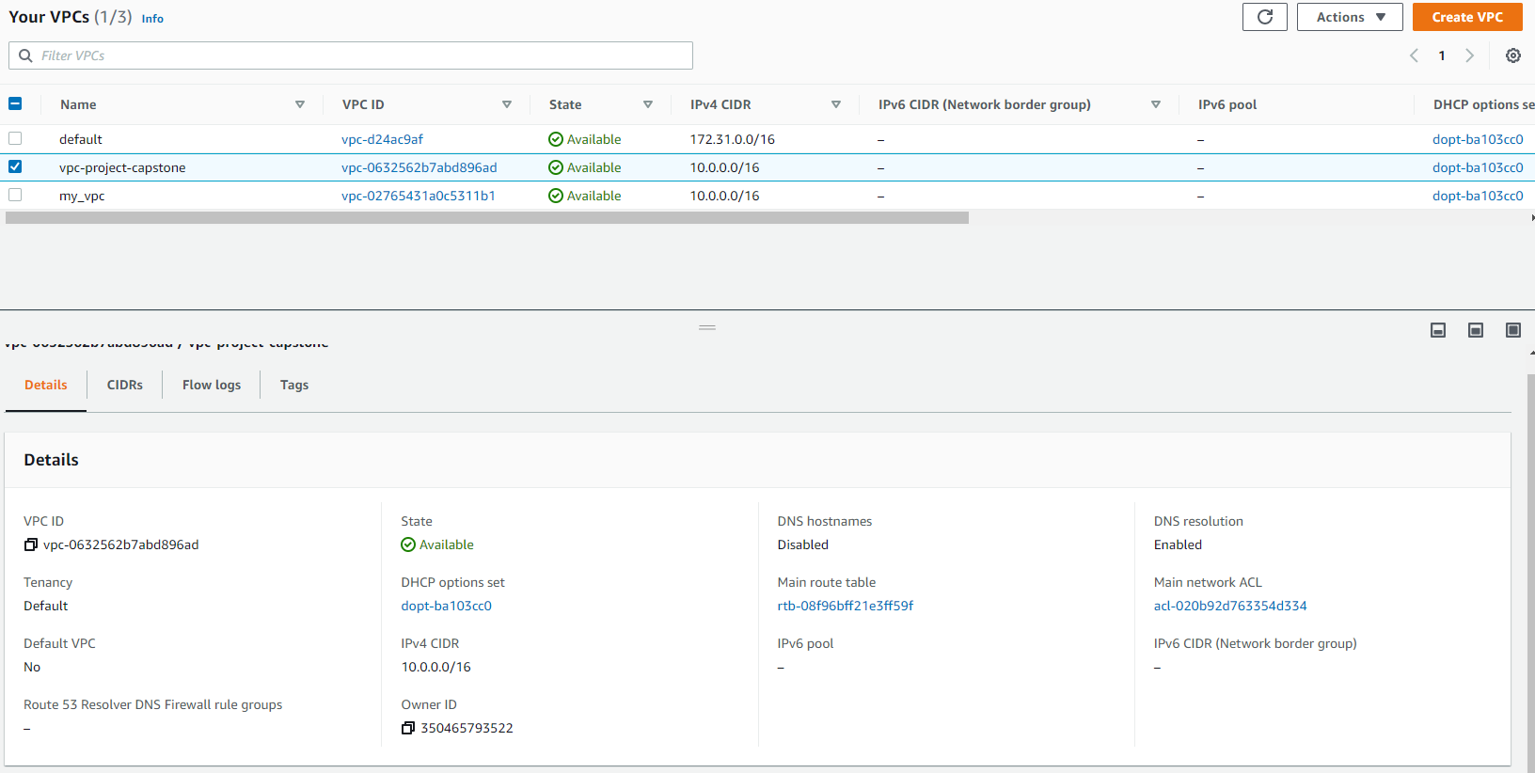

Subnets

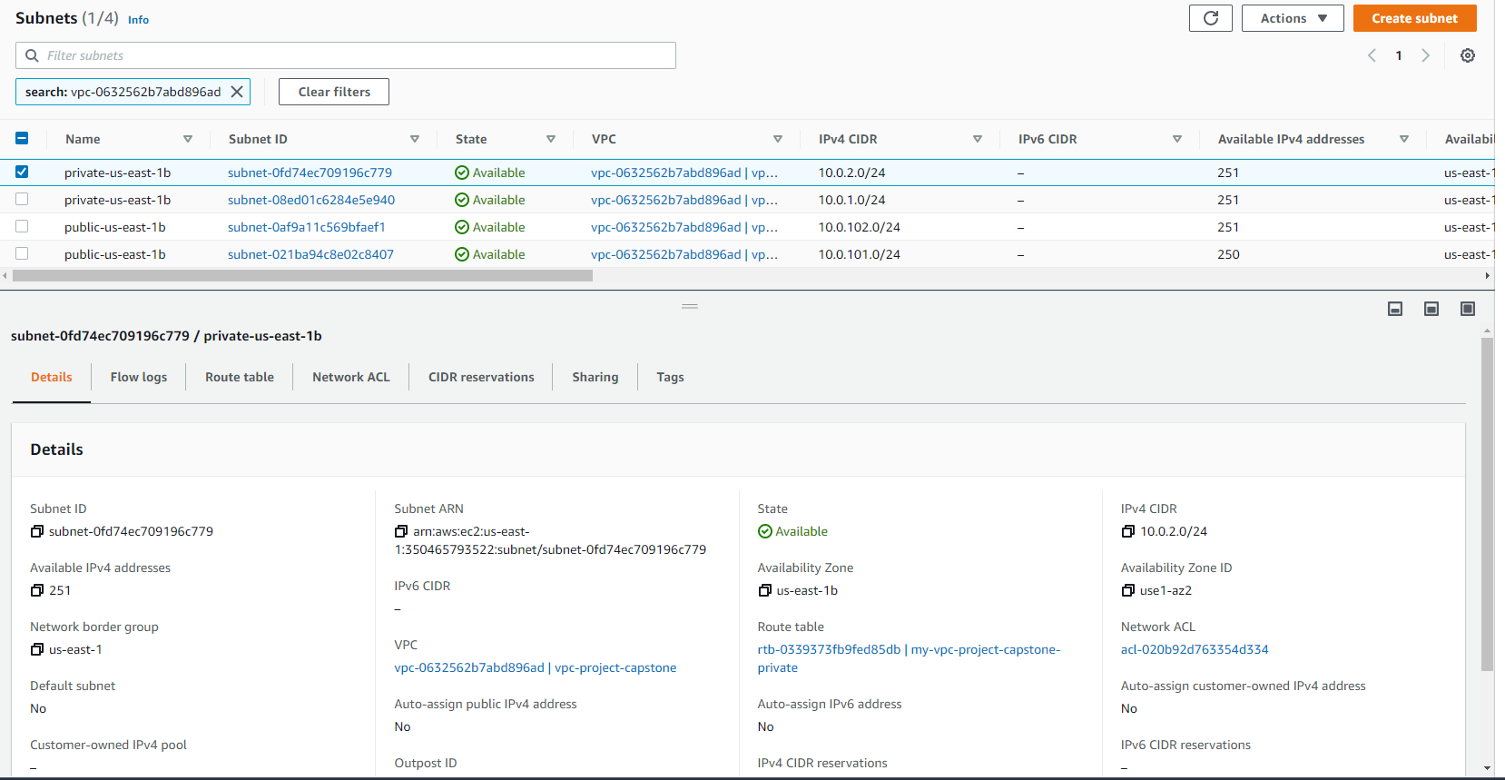

Subnets tags

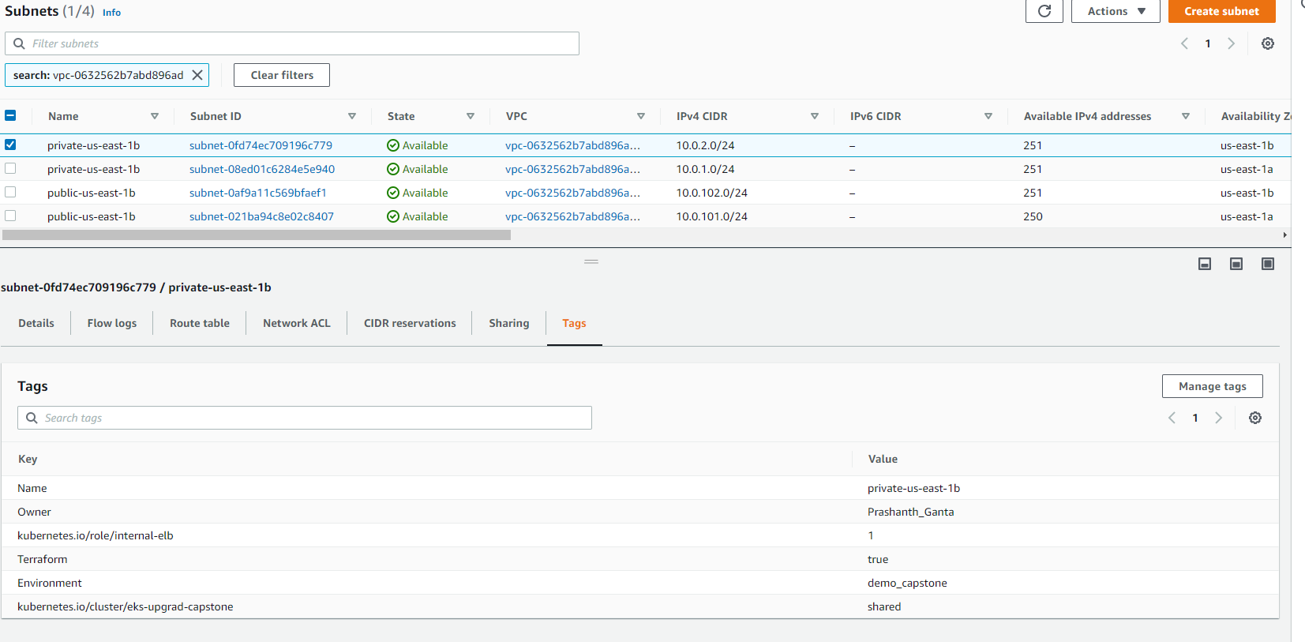

Nat Gateway

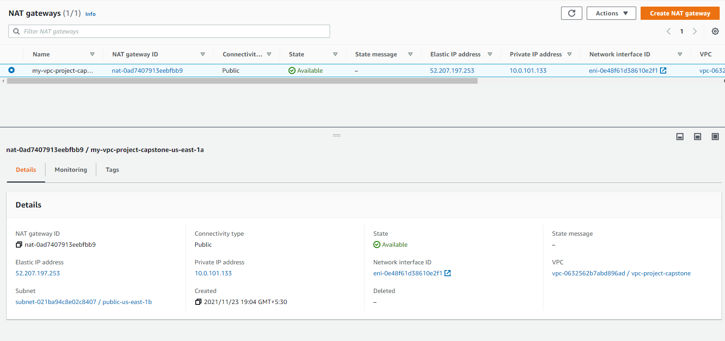

Eksctl setup



**Creating AWS EKS Cluster**

My-eks-conf.yaml

Provide the VPC and Subnets details created with VPC in cluster file according to requirements

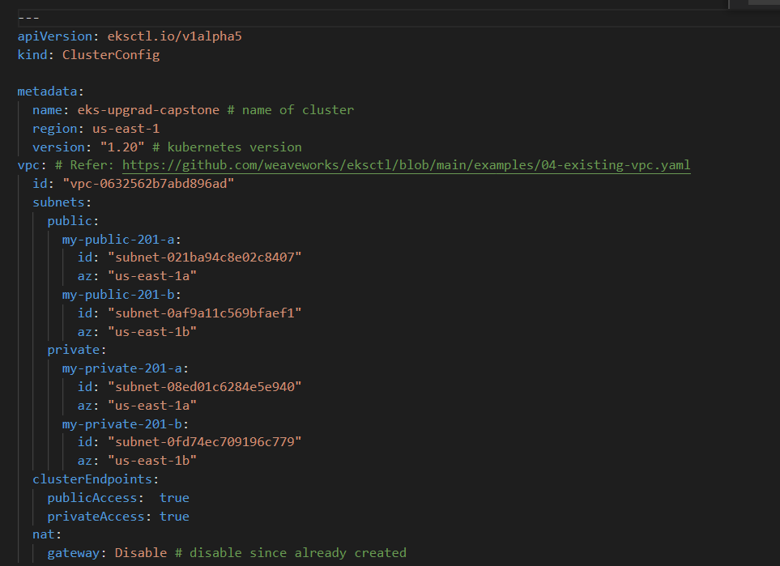

Run: eksctl create cluster -f my-eks-conf.yaml

Or run: make create_cluster (this is the direct method of running the files with make command)

Wait for 15-20 minutes

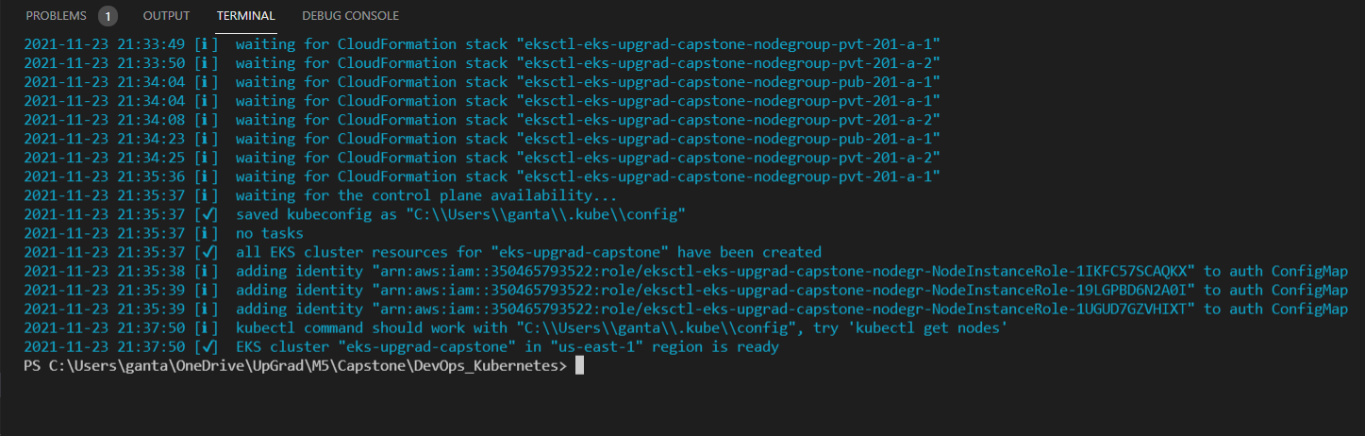

EKS cluster in console

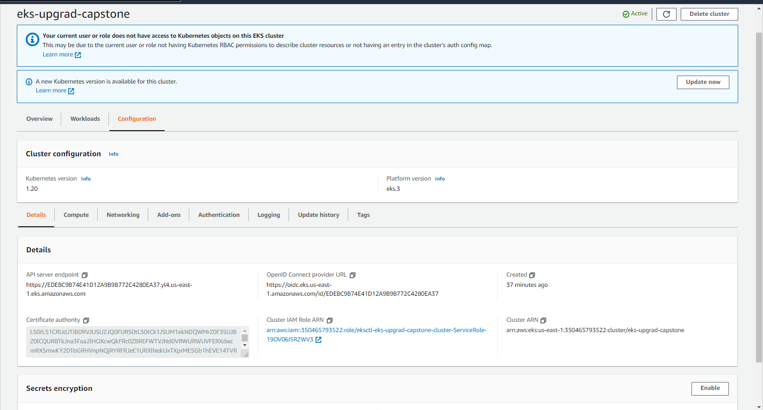

Install the following add ons to the EKS cluster:

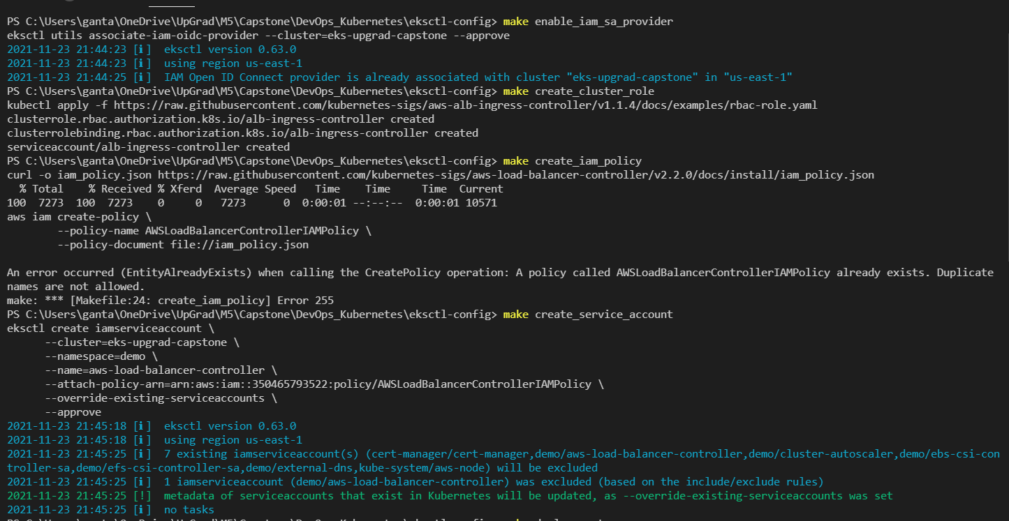

Deploying Cert manager

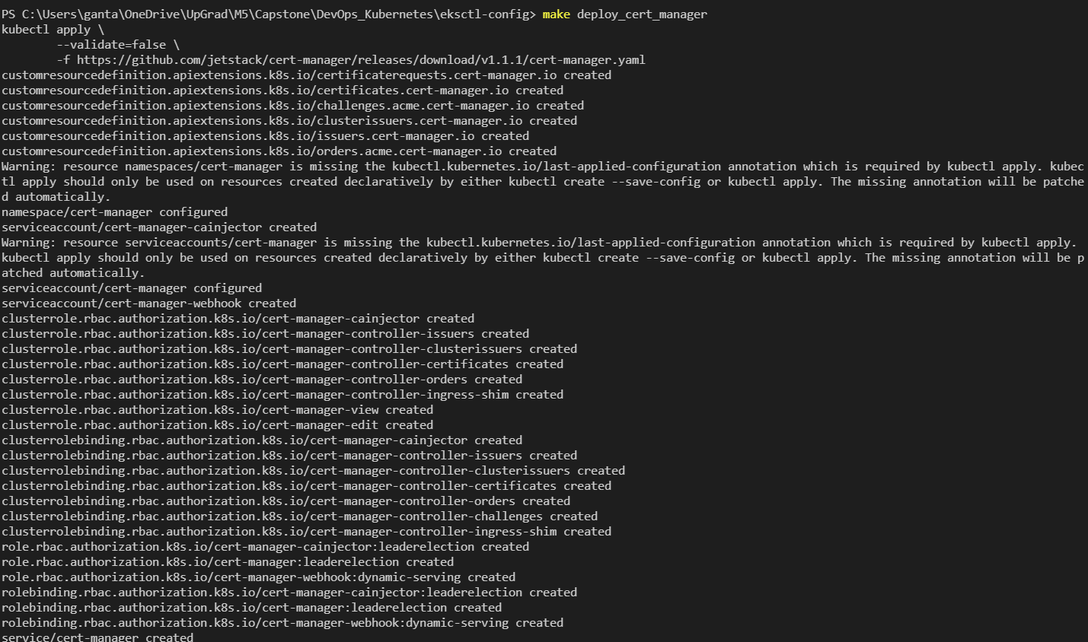

Deploying Ingress controller

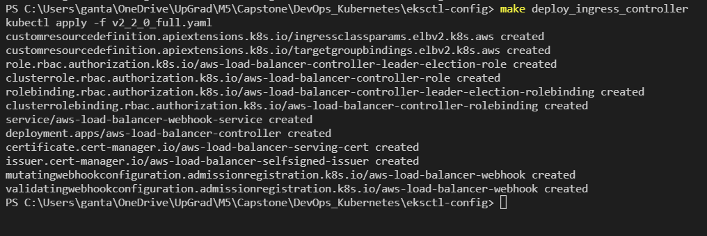

**Task 2: Deployment of sample application**

Creating Docker file and deploying into ECR

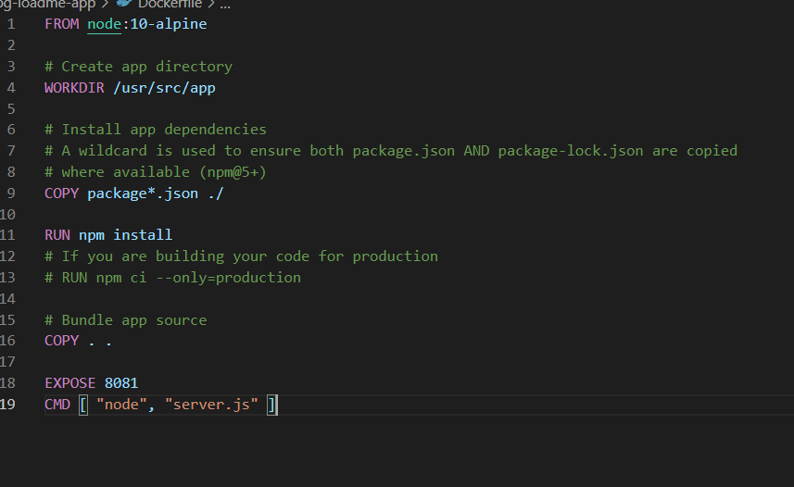

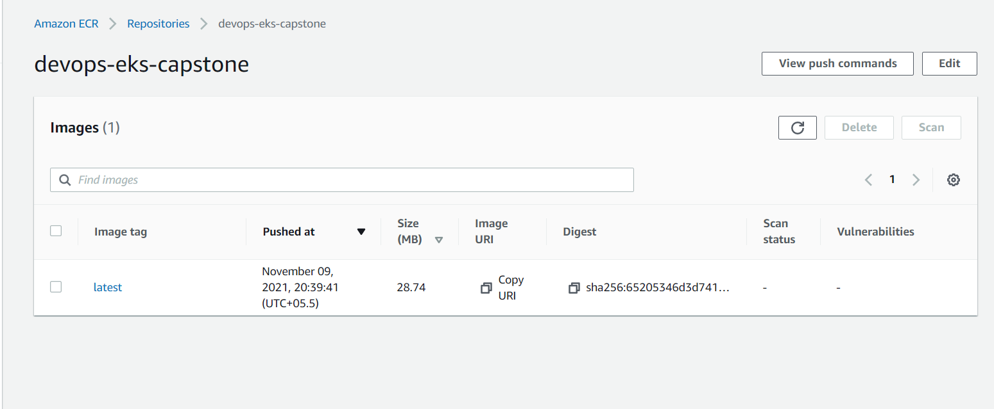

Deploying upg-loadme.yaml and upg-loadme-ingress.yaml files

eksctl apply –f "upg-loadme.yaml”

eksctl apply –f “upg-loadme-ingress.yaml”

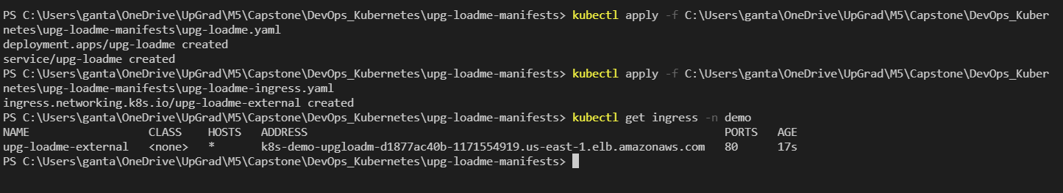

Load-balancer end point:

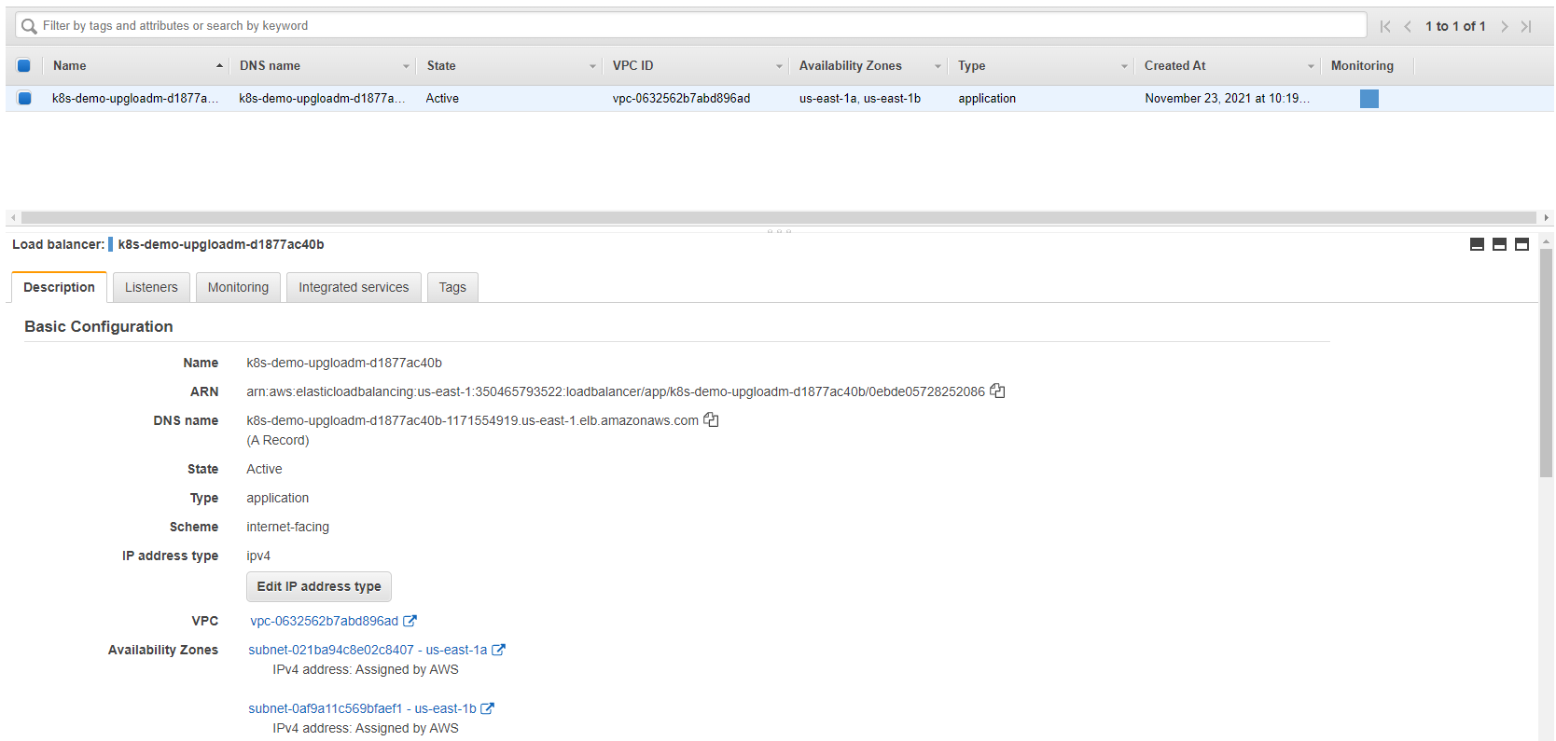

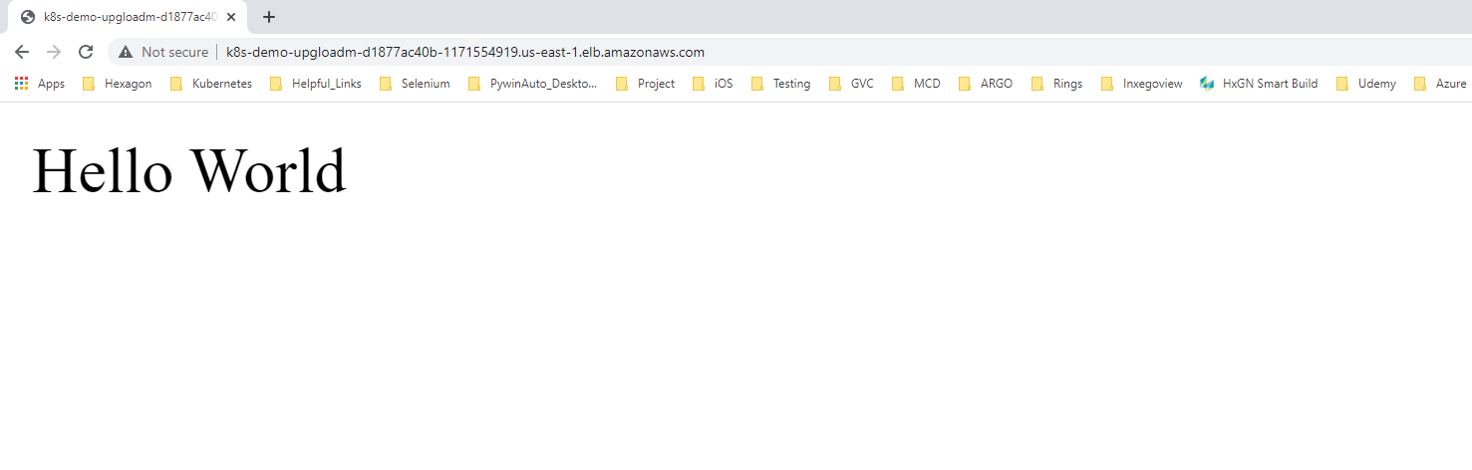

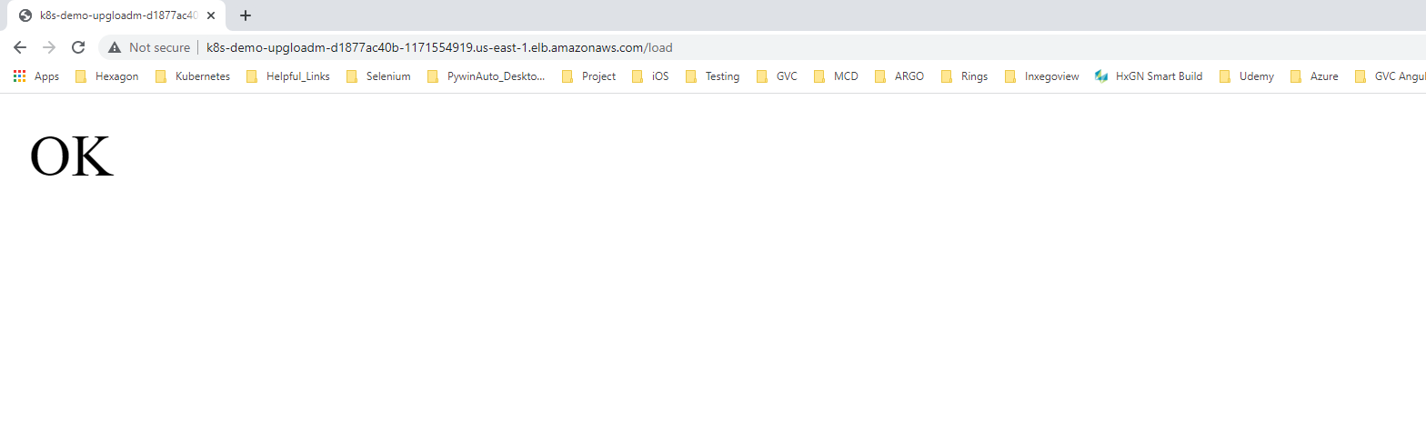

**Task 3: Deploy Redis server on Kubernetes**

Redis-server:

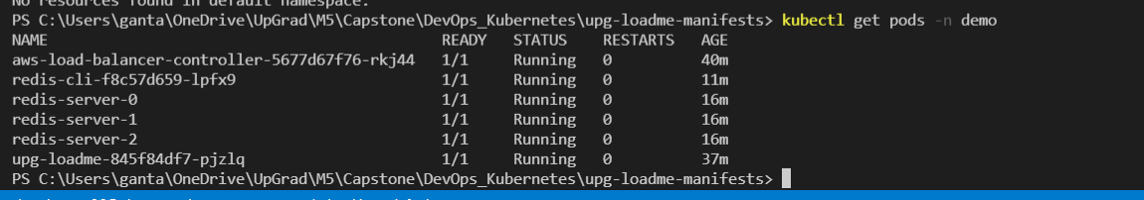

Redis-server:

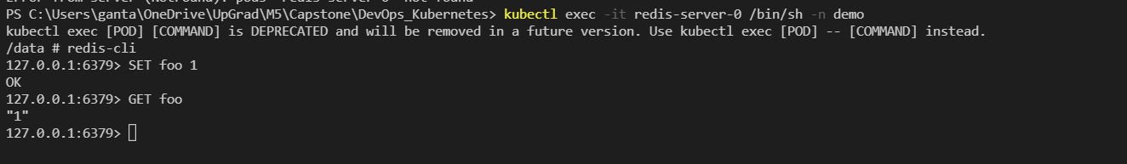

Redis-cli:

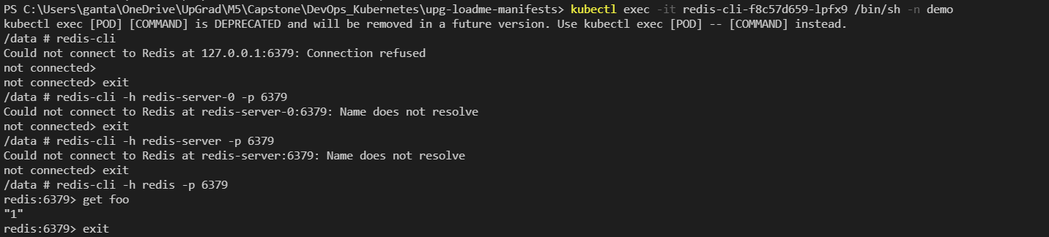

**Task 4: Test auto scaling of the application.**

Metrics server deploying:

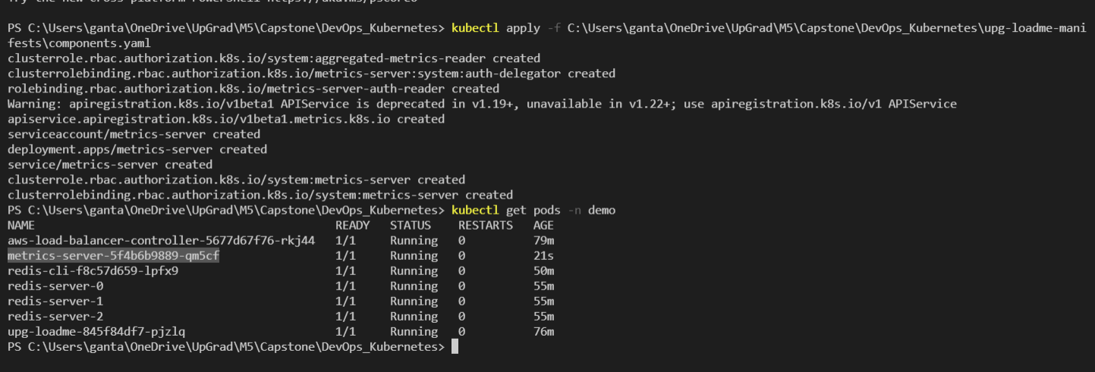

helm repo add metrics-server <https://kubernetes-sigs.github.io/metrics-server/>

helm upgrade --install metrics-server metrics-server/metrics-server --namespace demo

Metrics server



Followed the below link and installed apache bench load testing

<https://www.digitalocean.com/community/tutorials/how-to-use-apachebench-to-do-load-testing-on-an-ubuntu-13-10-vps>

Load increase with ab  
ab -n100 -c10 'http://k8s-demo-upgloadm-d1877ac40b-1171554919.us-east-1.elb.amazonaws.com/load?scale=100'

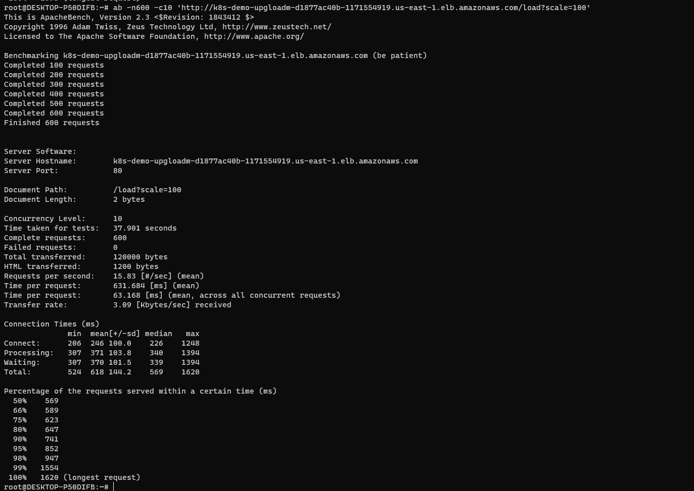

After increasing load, hpa scaling

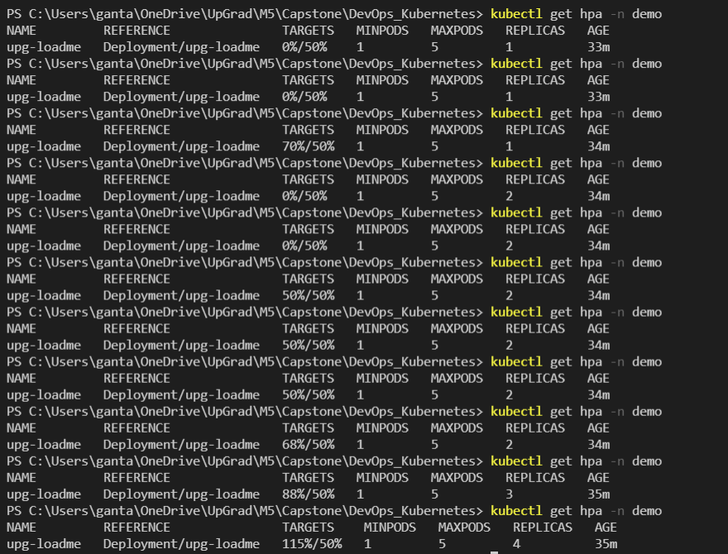

ab -n300 -c10 'http://k8s-demo-upgloadm-d1877ac40b-1171554919.us-east-1.elb.amazonaws.com/load?scale=300'

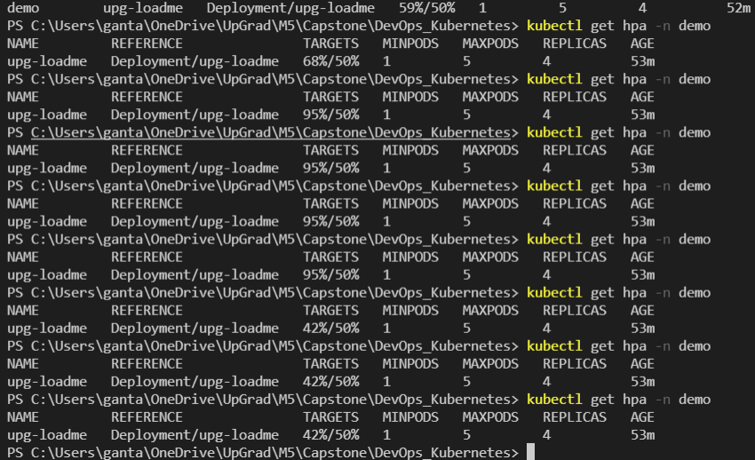

Load decreases according to the requests

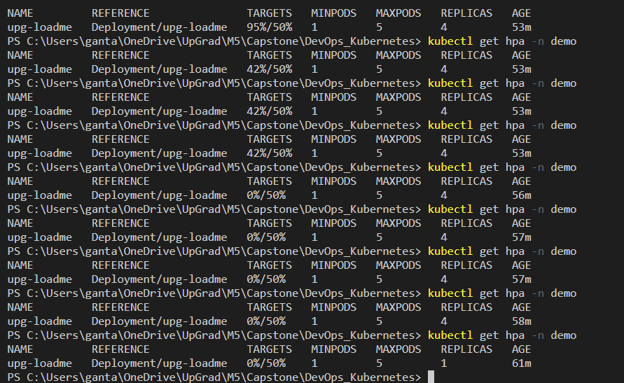

Top Pods in AWS -EKS

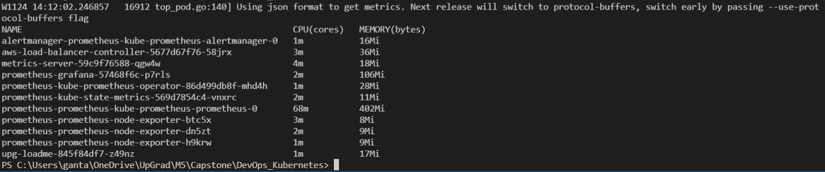

Port forwarding:

Forwarding 3000 and 9090 ports to access dashboards

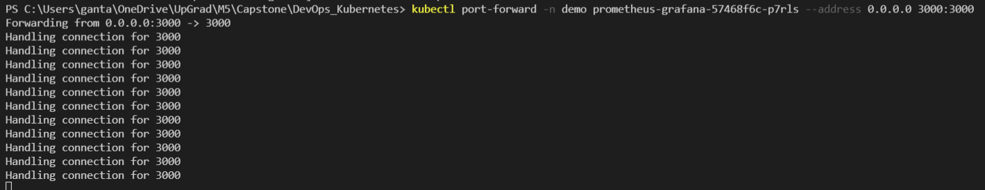

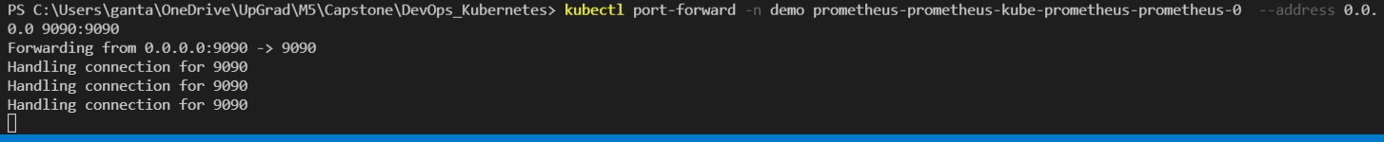

Grafana-Prometheus-Dashboard

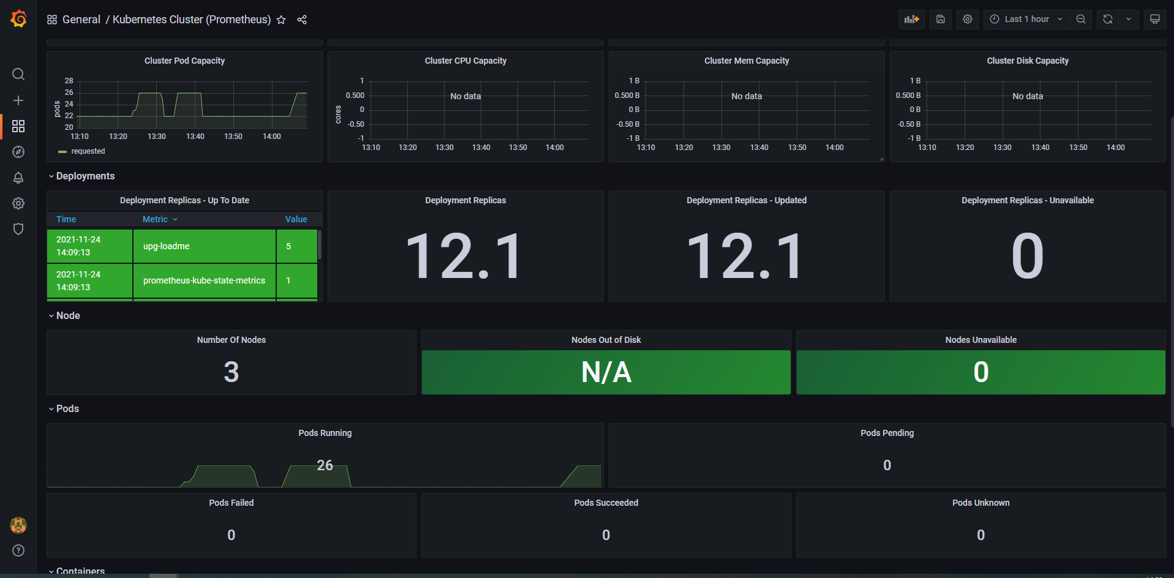

[Prometheus](http://localhost:9090/graph) Dashboard

